Chinese New Year
(Sing to the tune of ‘Frére Jacques’)
Chinese New Year, Chinese New Year,
Let’s have fun!, Let’s have fun!
Time for friends and family, time for friend and family,
Everyone, everyone!
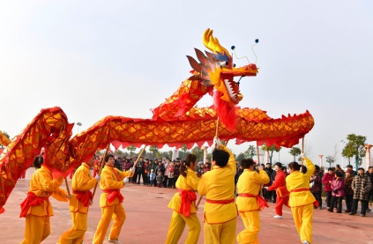
Chinese New Year, Chinese New Year,
Hear the drum, hear the drum!
See the dragons dancing, see the dragons dancing,
Here they come, here they come.

Chinese New Year, Chinese New Year,
Red and gold, red and gold.
Lots of coloured lanterns, lots of coloured lanterns,
To behold, to behold!

Chinese New Year, Chinese New Year,
In the sky, in the sky,
There are noisy rockets, there are noisy rockets,
Way up high, way up high.

